Making AI Work for You in Your Job Search
By Bryan Blair
I sit on the hiring side of the table. As an executive search consultant in biotech and pharmaceutical R&D, I review hundreds of candidate profiles a year and guide hiring decisions for roles from clinical team managers to C-suite executives. What follows is not theoretical. It is what I see working and not working every week.
Most job seekers fall into one of two camps with AI right now. The first camp ignores it entirely, relying on the same application strategy they used five years ago. The second camp uses ChatGPT to write their cover letters, rewrite their resumes, and generate interview answers, which makes them sound less like themselves and more like everyone else. Both camps are losing.
There is a third approach: use AI as your research and preparation engine, not your ghostwriter.

Understand what you are preparing for
Before we talk tools, you need to understand what happens on the other side. When a recruiter opens your resume, the first scan takes ten to twenty seconds. They check your most recent title, the type of company you worked for, your industry, your seniority, and whether anything looks misaligned. That scan decides if you stay in the game or disappear into the volume.
Hiring managers shape this process before you ever reach an interview. They set preferences that may never appear in the job posting: preferred industries, required tools, specific domain experience, team structure familiarity. Recruiters filter based on what the manager says the team needs, not on their personal opinion. A strong resume still gets passed over when the relevance is not obvious.
This is exactly where AI becomes your advantage. Not to write for you, but to help you see what others see when they read your application.

Let AI analyze the gap, not fill it
Take the job description. Paste it into a paid large language model like ChatGPT or Claude. Then attach your CV and any research you have gathered on the company. Give the model a structured prompt that asks it to analyze alignment between your experience and the role, identify gaps, and produce a tailored version of your CV that emphasizes the most relevant experience without fabricating anything.
To help you get started, here is a prompt framework I built for exactly this purpose:
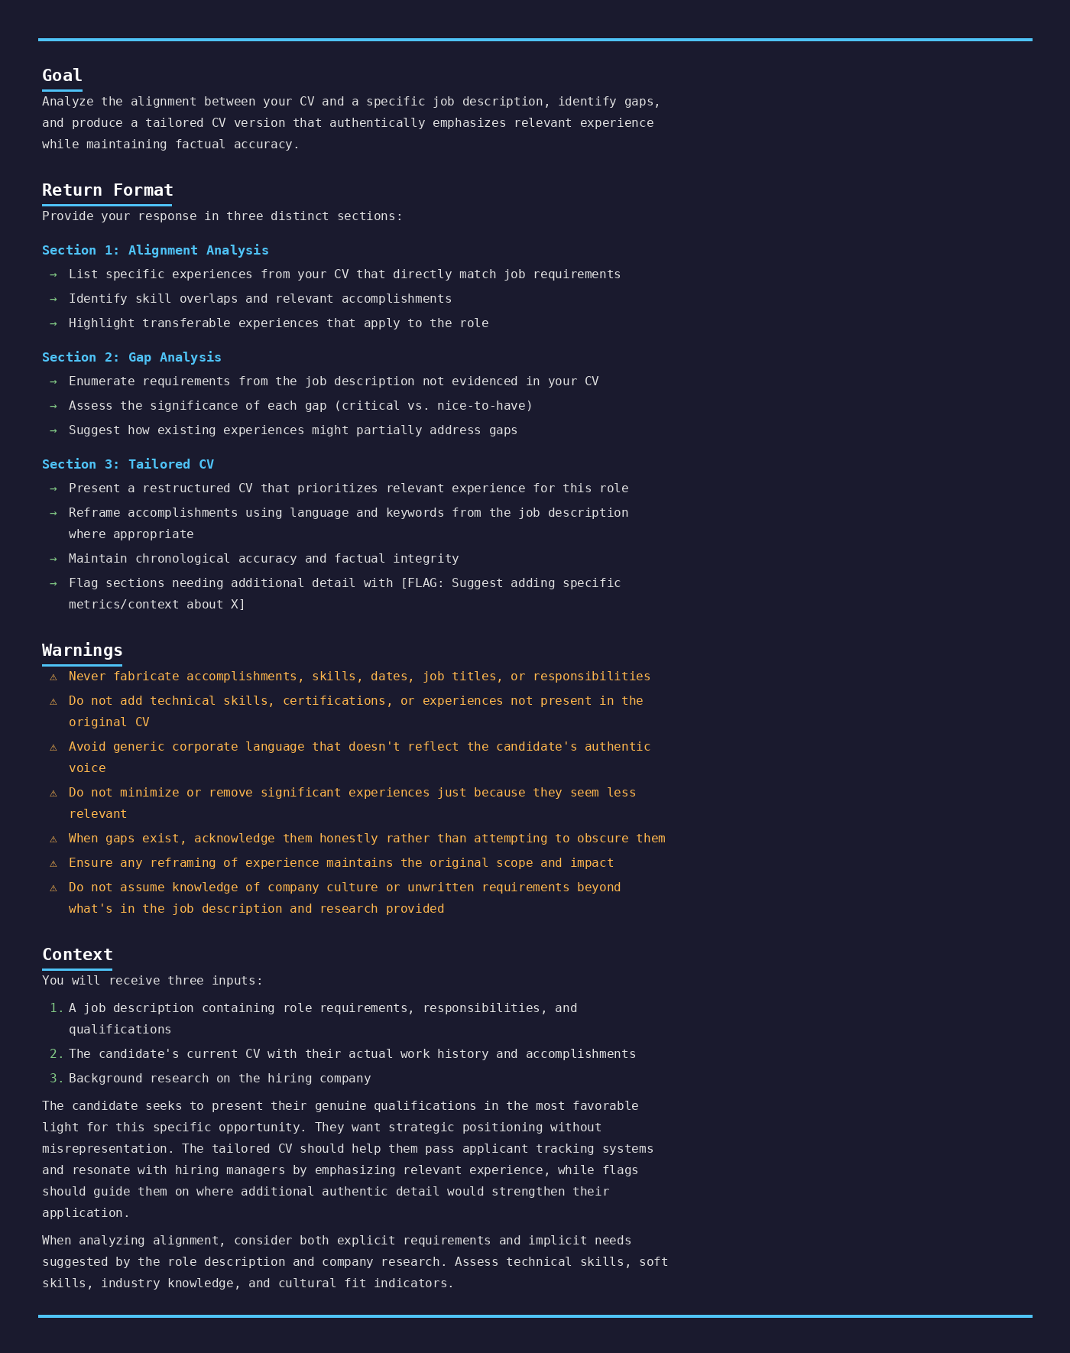
What comes back will not be a finished product, but it will be a dramatically better starting point than what most candidates work from. It forces a structured comparison between what the company needs and what you bring, highlights the alignment a recruiter would look for in that ten-to-twenty second scan, and surfaces gaps you can address before you apply.
I stress paid tools here for a reason. Free versions of large language models have limited reasoning and shorter context windows. If you are in an active job search, a $20 monthly subscription is one of the highest-ROI investments you can make.
The critical distinction: do not copy and paste the AI output blindly. Review it. Edit it. Make sure every line reflects something real about your experience. Hiring managers and recruiters can tell when a document has been AI-generated. The language gets flattened, the specificity disappears, and the person's actual voice vanishes. Relevance beats polish every time. Use the AI draft as a mirror that shows you what to emphasize, then make the final version yours.

Research like a consultant, not a candidate
Before any interview, you should know more about the company than the job posting tells you. Remember those invisible hiring manager preferences? Research is how you uncover them.
Perplexity is especially useful here because it pulls from current sources and cites them, making it easy to verify what you read. Use it to understand a company's recent funding, pipeline milestones, leadership changes, and competitive landscape.
For those in clinical research and drug development, Claude now integrates with ClinicalTrials.gov through its connector tools. You can research a company's active trials, phases, therapeutic areas, and enrollment status in minutes. When you walk into an interview referencing specific details about their development pipeline, you are no longer a generic applicant. You are someone who did the work.
The standard for interview preparation has shifted. What used to take hours of digging through press releases and investor presentations now takes minutes. AI removed the excuse for not doing that research.

The real competitive advantage
The concern I hear most often from candidates is that AI is making hiring less human. The anxiety is understandable, but the reality is more nuanced. On the employer side, most fast rejections come from knockout questions and basic eligibility filters, not from AI scoring your resume. A visa requirement, a location mismatch, or a missing certification triggers an automatic decision before anyone reads your application. The system is more mechanical than most people assume.
On the candidate side, AI gives you something that was previously only accessible to people with deep networks or expensive career coaches: the ability to prepare at a level that matches how hiring actually works.
The candidates who stand out in my searches are not the ones with AI-polished resumes. They are the ones who show up having researched the company's pipeline, who articulate exactly why their experience maps to the role, and who ask questions that signal genuine understanding. AI did not replace the work of being a compelling candidate. It made the preparation faster.
Use these tools the way a good consultant would: for research, analysis, and preparation. Then show up and be yourself. That combination is harder to compete with than most people realize.

